Developing Custom Windows Forms Controls with the .NET Framework

It needs to develop a MultiType Table List what will be used in NI Labview as control. It must work on all type of Windows.

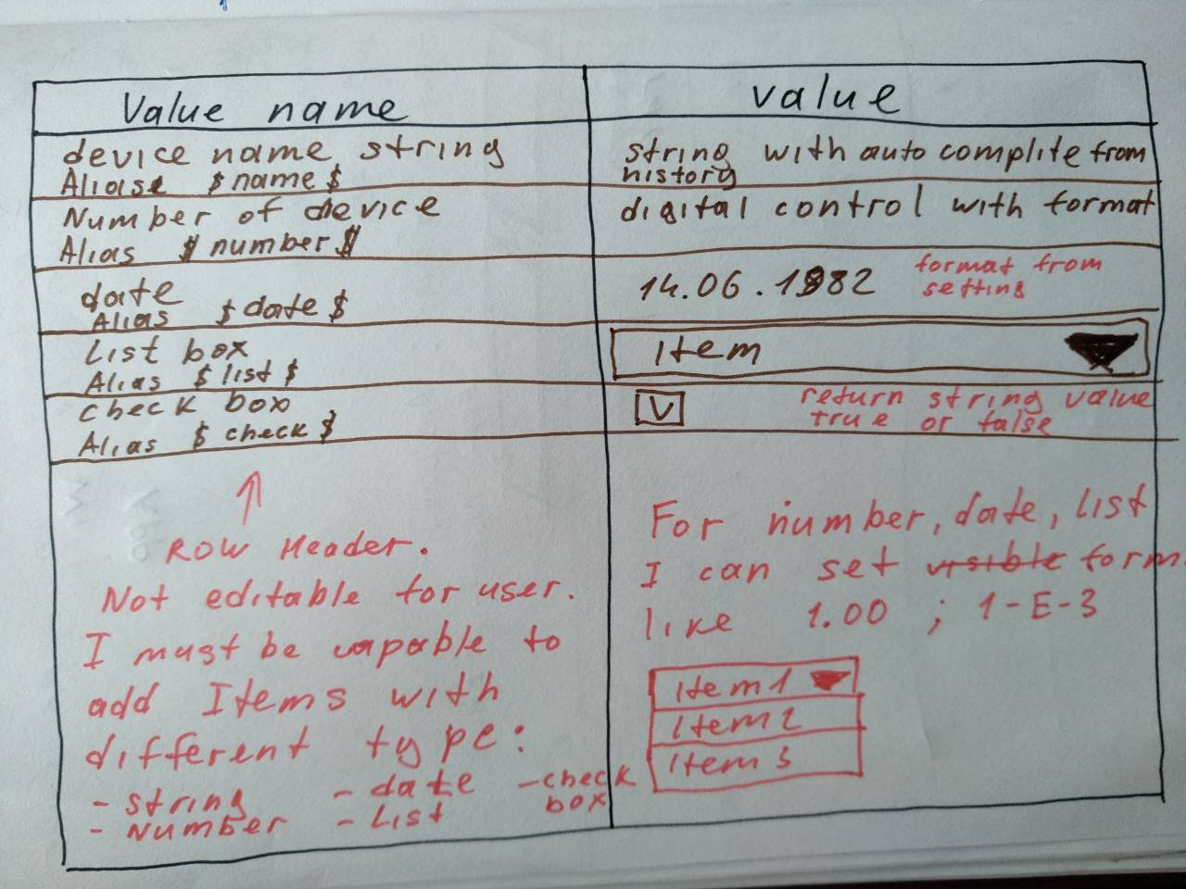

TableList will be used for user input of parameters with different type.

|  |  |  |  |
| --- | --- | --- | --- |
| # | Type | Available property | Description |
|  | String | * Max size – number * History – array of string for autocomplete * AutoCompeteEn – En\Dis | User can write any string with size limit |
|  | Number | * Format expressed in string (take popular system) | Number field with user specific format |
|  | Date\time | * Format expressed in string (take popular system) | Timestamp field with user specific format |
|  | Listbox | * Items – array of string | When user click on it, listbox with all item should be showed |
|  | Checkbox | * StrValue – string representation of True or False. For example ok | not on. |  |

For each items I can set “name”, “alias” as string value. Name and Alias must be showed in row name like on picture.

Control must support TAB, ENTER, DOWN, UP buttons. When pressed cursor go to next editable item.

String must support autocomplitition from history.

I must be able to get all\one items value like array of string.

I must be able to set all\one items value like string for value preset.

WinForm must support auto resizing.